ORDER OF SERVICE

Prelude Adagio from Symphony No. 3, Op. 28 Louis Vierne

Gathering Rev. Grace Imathiu

Word of Grace

Greeting

+Hymn UMH 77 “How Great Thou Art”

Prayer Rev. Brittany Isaac, District Superintendent

PROCLAMATION AND RESPONSE
Psalm 23 UMH 754

Old Testament Lesson Tim Owen, nephew
Isaiah 40:1-5, 28-31

New Testament Lessons Sue Owen, niece
Luke 24:13-35 and Romans 8:31-32, 35-39

Sermon Rev. Bonny Roth

Anthem And I saw a new heaven Edgar Bainton

Witness
Jennifer Keller, Rev. Danita R. Anderson, Rev. Martin Deppe and Pastor Thomas Cross, Alice Lonoff, John Keller
Jennifer Keller, daughter
*Rev. Tom Cross & Rev. Martin Deppe
*Rev. Danita Anderson, Pastor at Woodridge UMC (former congregation)
Grew up in congregation (her mother, Doris Anderson was membership sec’y) of Grace UMC,
Gresham-Auburn Park
*Sue Owen, niece
*Jo
Jennifer Keller, daughter
*Rev. Tom Cross & Rev. Martin Deppe
*Rev. Danita Anderson, Pastor at Woodridge UMC (former congregation)
Grew up in congregation (her mother, Doris Anderson was membership sec’y) of Grace UMC,
Gresham-Auburn Park
*Sue Owen, niece
*Jo
Jennifer Keller, daughter
*Rev. Tom Cross & Rev. Martin Deppe
*Rev. Danita Anderson, Pastor at Woodridge UMC (former congregation)
Grew up in congregation (her mother, Doris Anderson was membership sec’y) of Grace UMC,
Gresham-Auburn Park
*Sue Owen, niece
*J

COMMENDATION
Anthem Thou wilt keep him in perfect peace
Samuel Sebastian Wesley

Prayers and The Lord’s Prayer UMH 895

+ Please stand as you are able.

+Hymn UMH 378 “Amazing Grace”

+Benediction
Christ went before us in death, as has our loved one,
Bob, showing us the way into eternal life.
We celebrate the good life we have shared with Bob.
God has given. God has received that which was loaned to us.
We are thankful for the good days we shared.
The grace of Jesus Christ, and the love of God, and the communion of the Holy Spirit be with us all.
Amen.

+Dismissal with Blessing

Postlude Fugue (“St. Anne”) in E-flat Major BWV 552
Johann Sebastian Bach
Musicians
Minister of Music & Organist: Dr. Brian Schoettler
Music Assistant: Cody Michael Bradley
Quartet: Sarah Fisk, Nicolette Nazarowski, Dennis Kalup,
David Wolfe

Rev. Robert Philip Keller
February 1, 1933 – April 25, 2022

Robert Philip Keller was born on February 1, 1933, and grew up in Liberty, NY, a small town 100 miles north of NYC. Bob was the son of Robert and Helen Keller, younger brother of Alda, and older brother of Polly. His family inspired his strong work ethic and his faith foundation in The United Methodist Church and contributed to his devotion to family and aspiration to serve others.
After academic and civic-minded leadership at Liberty High School, Bob graduated with honors as class valedictorian. He earned an undergraduate degree in mathematics from Bucknell University, Lewisburg, PA. Responding to God’s call to ministry, Bob graduated from Yale Divinity School in New Haven, CT, with a Masters in Divinity. Shortly after graduation, Bob married Rosemary Skinner, a classmate at Yale. They enjoyed a happy and fulfilling marriage of 49 years until her death in 2008.
Bob first served four years in the Troy Conference in a two-parish appointment in Pittsford and Chittenden, VT. In 1962, Bob and Rosemary moved to Chicago’s southside where their two children, Jennifer and John, were born.
Bob’s first appointment in the Northern Illinois Conference was to Grace Methodist Church in the Gresham-Auburn Park neighborhood. Working closely with church, community, clergy and individuals, his devotion to civil rights was set in motion. Bob was a part of Operation Breadbasket (1966-1971), founded by Dr. Martin Luther King, Jr. He was also active in the Renewal Caucus, which became United Methodists for Church Renewal. With Rev. Jerry Forshey he was co-pastor of the experimental congregation Church of the New City.
Bob served senior pastor appointments in Chicago, Aurora, Woodridge, Northbrook and Ravenswood and interim appointments in Oak Park, Highland Park and Rockford, then moved to New York City, with his wife, Rosemary who was appointed academic dean at Union Theological Seminary. There he served part-time appointments in Harlem, Washington Park and Bridge Hampton. Bob and Rosemary loved teaching Bible classes and group studies, as partners in writing and ministry with congregation and community. He retired at age 79 as pastor of pastoral care at First UMC, Evanston, IL.
While he was a passionate pastor in the civil rights movement, a voice for equality, and a leader in opening avenues for gainful employment, Bob also worked for full inclusion of all people. As part of Reconciling Ministries, Bob represented the church in Chicago’s Gay Pride Parade, riding in the Euclid Avenue UMC, Oak Park, parade float.
Bob’s greatest love was serving as a pastor, loving God, sharing the Good News of the Gospel, and helping people in their greatest time of need. His delightful sense of humor was treasured by his family and friends. A devoted sports fan, partial to the Chicago Bears, Chicago White Sox, Chicago Bulls, and Northwestern University Wildcats, he spent many hours rooting for his favorite teams. He was a wonderful father to Jennifer and John, loving father-in-law to Melissa (John’s wife), and a devoted grandfather to Conner and Cameron Keller. He is also survived by his sister Polly, who lives in Trumbull, CT, as well as his six nieces and nephews, and grandnieces and grandnephews. Bob was buried next to his beloved Rosemary at Rosehill Cemetery on May 1.
Contributions may be made to Ravenswood Fellowship UMC or to Garrett-Evangelical Theological Seminary for one of the following designations: The Rosemary Skinner Keller Endowed Scholarship or The Center for Church and the Black Experience (CBE).

Memorial Service in
Celebration of the Life of
Robert P. Keller
February 1, 1933 - April 25, 2022
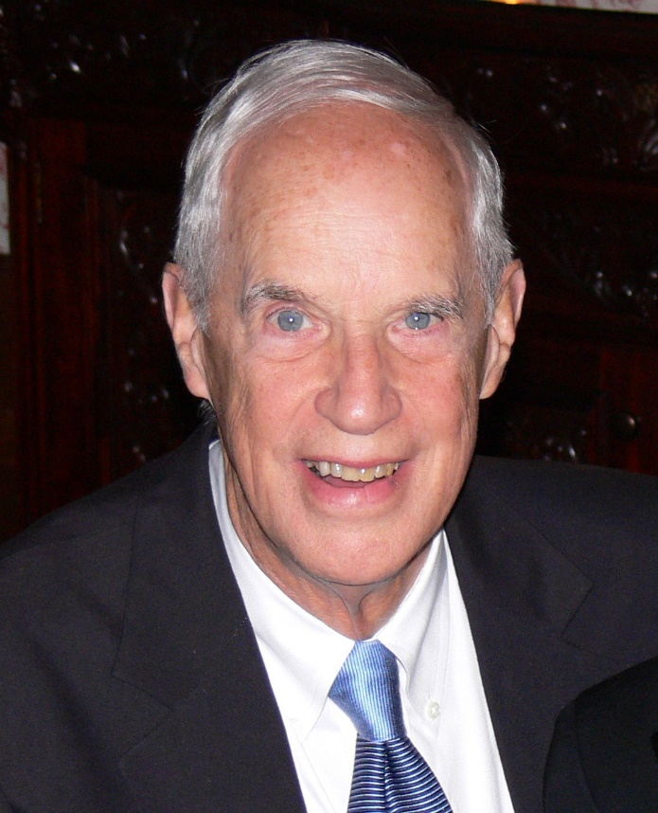

First United Methodist Church
516 Church Street
Evanston, IL 60201
June 5, 2022 at 3:00 p.m.

